# General skills

* Giving examples: Must be short, emphasize on the issue and not the example
* Expand on the source given to elaborate

**Examples:**

1. Source focus on feature of incinerator → describe the positive and negative impacts and extend to answer question
2. Source given result of policy → retrace the elaboration from the beginning cause of result

**ADDRESS EVERY QUESTION KEYWORD**

##### Stance (Agree / Disagree)

##### Reasons & impacts

##### Identify concerns

##### Data analysis

# Conflicts

* Identify the point of conflict
* Identify stakeholders with conflict
* Give examples of the scheme related to the stakeholder’s value / concern
* Elaborate within the concerns
* State why the two values / modifications are incompatible with each other

#### Outline

#Scheme# is a controversial issue that involves multi-stakeholders. The following points of conflict #Conflict1# and #Conflict2# will be discussed.

On the #Conflict1#, there is a conflict in [#TypeOfConflict] the #stakeholder1# concern over the #concern1# with conflicts with the #stakeholder2#’s value.

1. The #stakeholder1# (thinks that … : supports the scheme)
2. [#SchemeExample]
3. [#Elaboration] //why stakeholder (thinks that … : supports the scheme)
4. However, #stakeholder2# (thinks that … : supports the scheme)
5. [#SchemeExample]
6. [#Elaboration]

Hence, the two are incompatible with each other, since [#Reason] [#Incompatibility]

Repeat(#stakeholder#n ++, 1) //repeat content once with different set of stakeholders

[#Conclusion] //restate the conflict, concerns and incompatibility

#### Types of conflict

|  |  |  |
| --- | --- | --- |
| 1. **Value** | 1. **Interest** | 1. **Execution** |
| Value of stakeholders | Interest of stakeholders | Features of the scheme |
| 1. Direction of development 2. Def of Social justice 3. Def of QoL | Harms the interest of a stakeholder | 1. Sufficiency of resources 2. Level of charge / compensation 3. Scale / coverage |

#### Incompatibility

* **Use situations**

**>** When level is high, harm #stakeholder1#, if low, harm #shakeholder2#

**>** Implementation can promote … if not, promote …

**>** Effective implementation → #effect#, but #effect# is not desired by #stakeholder1# → not implement, but is not desired by #stakeholder2#

* To answer the conflict aspect of the question

#### Conflict examples / Reasons

* Envt gps & grass root → level of charge | Reason = “charge must be standardized”
* Middle & grass root → QoL definition | Reason = “”
* Govt & cleaners → Resource sufficiency | Reason “different values”
  + Resource = “Manpower / guidelines” → ↑ workload

# Sustainable development

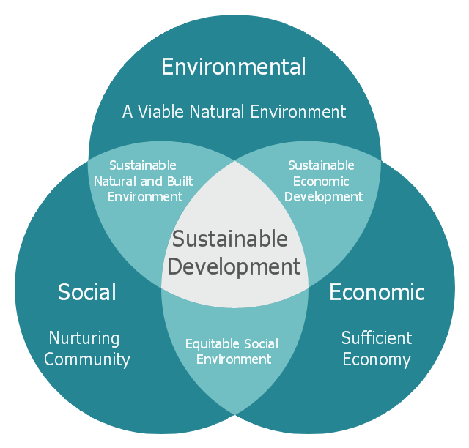

|  |  |
| --- | --- |
| Environmental | Consumption of natural resources within ecological carrying capacity  Reduce pollution // long run environmental protection  Greening  Biodiversity |
| Social | Social justice, equality // reduce social conflict, avoid controversies  Balanced development  Long-term consideration  Whole society as consideration |
| Economic | Long-term economic benefits // other use of resources or land  Minimize after cost // high return  Cost-efficiency  Innovative industry |

#### Outline

I #Stance#.

1. In terms of [#SusAspect], it can [#SusAspect:item]
2. According to source, [Source:Relevant]
3. [#Elaboration]
4. [#SusAspect:Link]

Repeat(#SusAspect#n ++, 2) //repeat content twice in another sustainable development aspect

# Comics

1. Respond to the question
2. Describe the comic (relevant part)
3. Elaboration → to apply to general situation, answering question with concepts

#### Decoding

|  |  |  |
| --- | --- | --- |
| Objects | With detail features | Relationship  Interaction  Comparison (size, bold, shape) |
| Characters | Emotions, dress code, appearance |
| Text | Dialogue, attitude, labels |